

|  |  |
| --- | --- |
| **April 8**  **10am-12pm**  **Easter Party (CEOS)** | **April 20**  **6pm-7pm**  **Open House** |
| **April 10**  **12pm-4pm**  **Magical Monday *(Spring Break Program)*** | **April 22**  **10am – 1pm**  **Studio Saturday – Painting Class** |
| **April 13**  **5pm-7pm**  **Movie Night – The Young Messiah** | **April 24**  **5pm – 6:30pm**  **Holocaust Remembrance Day Presentation** |

|  |
| --- |
| **Thursdays**  **1pm – 3pm**  **Knit-Wits** |

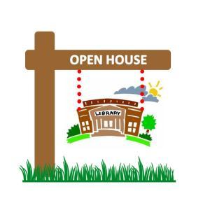

*Open House*

Thursday, April 20th at 6pm.

What do YOU think? We would like to invite the McClellan District to come together and share some thoughts and ideas on how our community can make greater use of our library. We’ll be sharing some of our ideas for future programming that we would like to see offered in our community as well as discussing what improvements and/or expansions could be made to our library to be of better service.

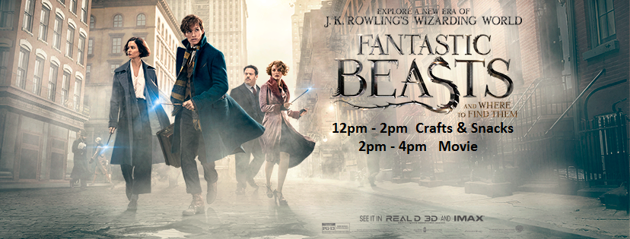

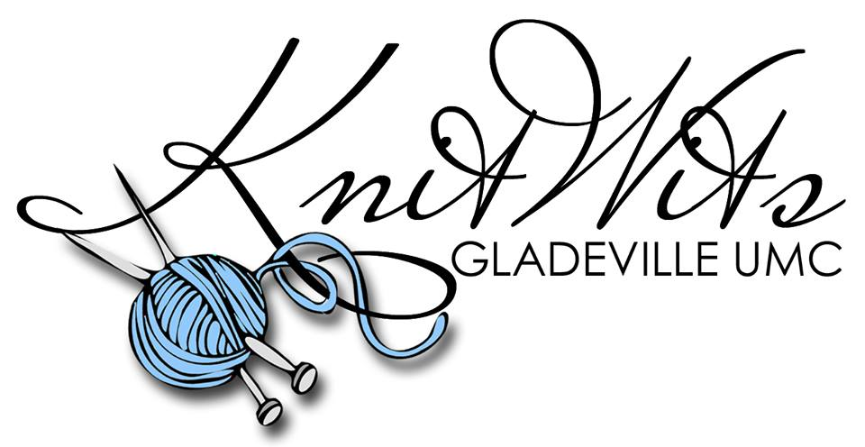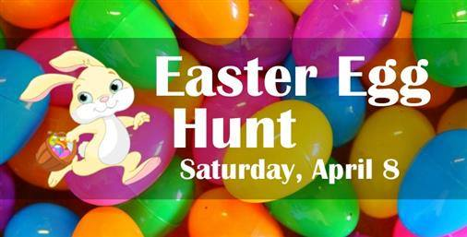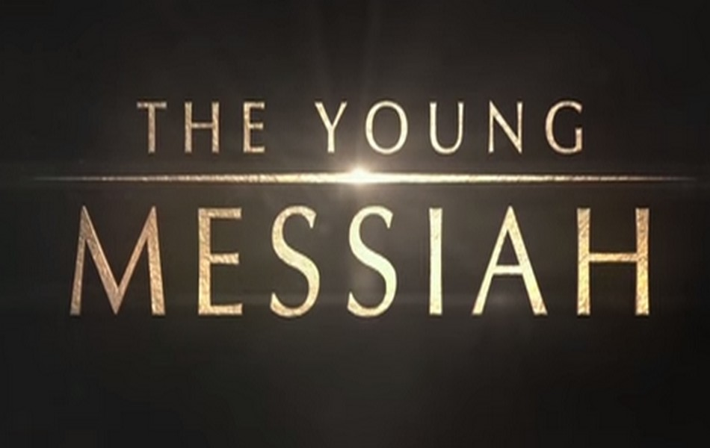

**Thursdays** from **1:00 -3:00** you can stop over at the library in Center Point and join in some **crocheting, knitting, cross stitch, even spinning**! We’ll have extra supplies and coffee!

*Easter Party (CEOS)*

Saturday

APRIL 8th  10am-12pm

Everyone welcome!

Easter Egg Hunt, games, prizes and crafts!

***Movie Night:* Thursday, APRIL 13th 5pm-7pm The Young Messiah *PG13***

*Inspired by Scripture and rooted in history, The Young Messiah imagines a year in the boyhood of Jesus. When the mystery of Jesus’ divinity begins to unfold in His early years, He turns to His parents for answers. Follow the young Messiah as He and His family take the extraordinary journey from Egypt to Nazareth and on to Jerusalem – where His true identity and profound destiny are revealed.*

**Monday , April 10th 12pm – 4pm**

**Make your own magic wand and then see if you can make a dragon appear! Maybe you’d rather have a new Pet ‘Bowtruckle’ to take home. Come spend the day ‘making magic’ with us!**

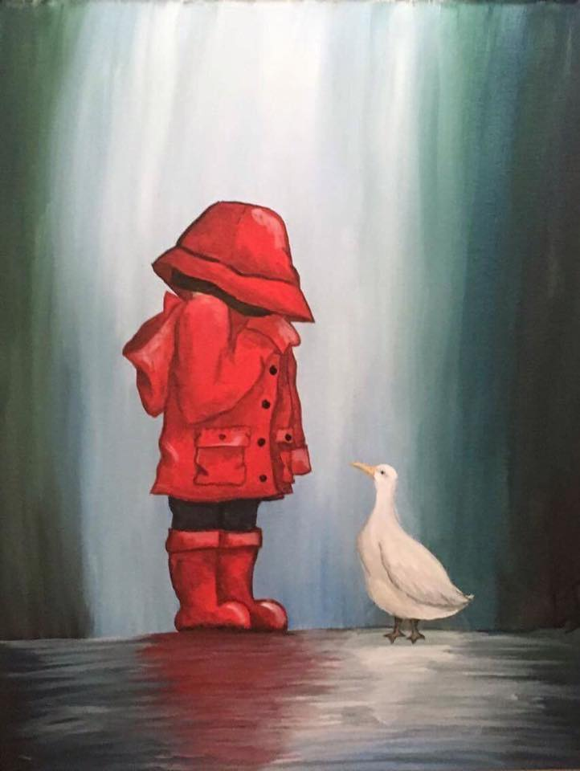

Painting Class

*Instructed by:* Lisa Ball

**Saturday**

**April 22**

**10am-1pm**

April 22

10am-1pm

Lisa Ball will once again be instructing a step-by-step painting class! ‘*April Showers’* is the theme for this painting of a child wearing a brightly colored rain hat playing in a puddle. We have 20 spaces available. Cost is $5.00 per person, due at registration. Don’t wait!

Give us a call at 304-782-2461 to pre-register!

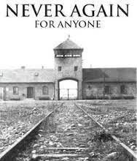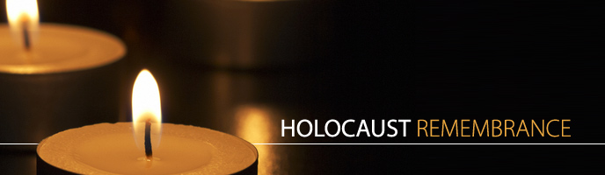

*Six Million Paper Clips Project*

Inspired by the book, *Six Million Paper Clips: The Making of a Children’s Holocaust Memorial* by Dagmar Schroeder-Hildebrand and Peter W. Schroeder; we would like to invite students and residents to participate in a county wide project to collect paperclips to represent the lives that were lost during the Holocaust. In effort to create a visual display that will inspire us to understand the importance of tolerance and the consequences of prejudice, apathy, and indifference; Students are encouraged to create sculptures and/or various works of art using paper clips.

These projects will be on display at the Center Point Library from April 24- 29 and then at the Doddridge County Library from May 1 – 6. Paperclips and projects will be received at Doddridge County and Center Point libraries until April 19th. Students will need to include their name and HOW MANY paperclips were used in their project.

*Holocaust Remembrance Day Presentation*

Monday, APRIL 24th 5pm – 6:30pm

Patricia Harris of Doddridge County Historical Society will be presenting.

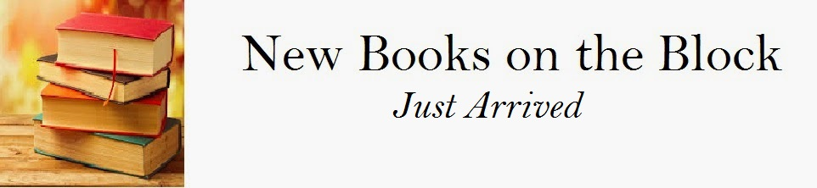

**FICTION**

***MYSTERY / SUSPENSE***

Before the Fall – Noah Hawley

The Bone Box – Faye Kellerman

The Drifter – Christine Lennon

Echoes In Death – J.D. Robb

Heartbreak Hotel – Jonathan Kellerman

Ill Will – Dan Chaon

The Secrets You Keep – Kate White

**\***Under the Knife – Kelly Parsons

Unpunished – Lisa Black

Mother’s Day Out – Karen MacInerney

***PYSCHOLOGICAL / THRILLER***

The Mirror Sisters (#1) – V.C. Andrews

Broken Glass (#2) – V.C. Andrews

***ROMANTIC***

Accidentally On Purpose – Jill Shalvis

#3 Heartbreaker Bay Series

Always – Sarah Jio

If Not for You – Debbie Macomber

***FICTION***

Every Wild Heart – Meg Donohue

***HISTORICAL***

The Dressmaker’s Dowry- Meredith Jaeger

Lincoln In the Bardo – George Saunders

Orphan Train – Christina Baker Kline

The Orphan’s Tale – Pam Jenoff

We Were the Lucky Ones – Georgia Hunter

**\***A Piece of the World – Christina Baker Kline

***INSPIRATIONAL***

With Love, Wherever You Are – Dandi Daley Mackall

Amish Wanderer – Laura V. Hilton

An Amish Home – Beth Wiseman

The Coming Home Series – Barbara Cameron

#1 Return to Paradise

#2 Seasons in Paradise

#3 Home to Paradise

***WESTERN FICTION***

Revelation - Robert B Parker’s – Robert Knott

**\*INCLUDES A REVIEW IN THE *LOCAL CORNER* SECTION**

**_________________________________________________________________________________________________**

**NON –FICTION**

***NON-FICTION***

***INSPIRATIONAL***

Good or God? – John Bevere

Why Good Without God Isn’t Enough

***CHILDRENS***

Six Million Paper Clips – Peter W. Schroeder

The Making of a Children’s Holocaust seum

50 States, 5000 Ideas – National Geographic

Where to go, When to go, What to See, What to do

Big Agenda – David Horowitz

President Trump’s Plan to Save America

***BIOGRAPHY***

Born a Crime – Trevor Noah

Night – Elie Wiesel



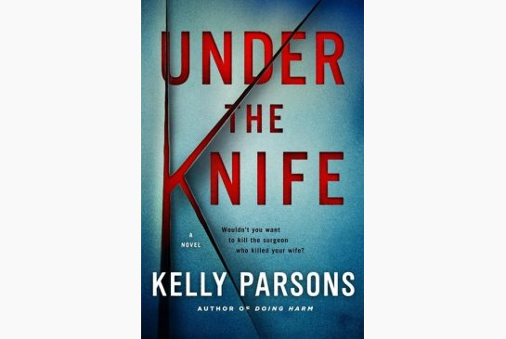

**Reviewed by Local Reader: *Linda Pitts***

**

*Stephen King wrote “ Best ---- medical thriller I’ve read in 25 years.”*

It’s good! Didn’t know what to expect after reading the prologue but it sucked me in from page one. I only skipped a few pages when it started to explain scientific information; but after that…real page turner! You have to wonder how far mankind will go in terms of medical technology. No spoiler alert here. This is a good novel. I hope you enjoy it as much as I did!

**Reviewed by Local Reader: *Linda Pitts***



There is something about this book that will draw you in until you have read every last page. *(Which I did read every last page and then I started to read it again.)* It’s based on facts and fiction. Most people know of or have heard of Andrew Wyeth, the painter/ artist and maybe one of his most famous paintings, *Christina’s World*. If not, that’s fine. There’s a picture of the painting in the back of the book. This is the story of that painting. Weaving facts and fiction, the author has done a magnificent job with the story’s characters but also of putting you in the story with them. You feel their love, pain, despair and hope. I didn’t want this story to end! On page 138 Andrew asks Christine ‘How does she think of herself?’ to which Christine answers, ‘I think of myself as a girl.’ Kind of like looking in the mirror and seeing an old woman looking back at you and you wonder where did the girl go? This book was profound and deeply moving for me. I hope it creates the same emotions in you when you read this powerful novel.

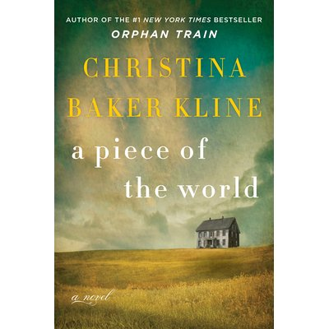

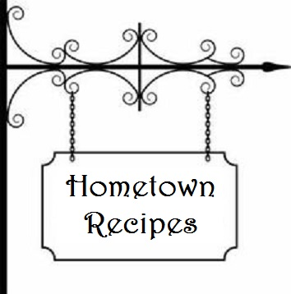

*OLD–FASHION AMMONIA COOKIES*

*In loving memory of Hazel Yeater*

**3 eggs, beaten 1 c. warm water**

**4 c. white sugar ½ oz. bottle oil of lemon**

**2 c. shortening 1 c. sweet milk**

**1 ½ oz. Baker’s ammonia**

Dissolve ammonia in warm water. Mix all ingredients together and add enough flour to make dough stiff enough to roll. Roll and cut with cookie cutter. Place on greased cookie sheet and pierce with fork. Piercing with fork is most important as it permits the ammonia to escape and makes the cookies rise. Bake at 400 degrees until lightly brown.

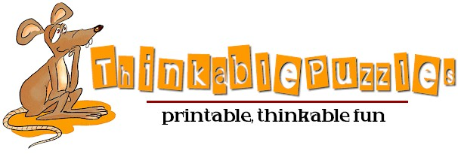



1. Somewhere Over the Rainbow 4. Just Right  
2. X Marks the Spot 5. I Before E Except After C  
3. Put two and two Together 6. High Seas