June 3  10am-1pm  3pm-6pm  Basket Weaving Workshop | June 22  1pm-2:30pm  Build a Better World – Summer Reading  Volunteering : Mike Davis
June 9  10am-2pm  Genealogy Workshop | June 23  10am-2pm  Genealogy Workshop
June 15  5pm-7pm  Summer Reading Kick-Off : Final Registration  Build a Better World  Movie Night – The LoraxPG | June 29  1pm-2:30pm  Build a Better World – Summer Reading  Community Clubs : Zona Hutson & 4HLeaders
June 22
‘BUILD A BETTER WORLD’
Summer Reading Program
Thursday, June 15
5pm KICK-OFF

SIGN-UP TODAY!! Students from 4-12 years old will enjoy fun stories, activities, crafts and snacks as well as meet some of our local community members who will be sharing what they are doing to ‘Build a Better World’!

5pm-7pm
Movie Night
The Shack
Friday, June 9th & 23rd 10am-2pm
If you have ever wanted to try Ancestry.com or wondered where to find information about your ancestry but you weren’t sure how or where to begin, then stop in to the library any time between 10am and 2pm on the above dates. Jennifer Wilt will be at the library to offer assistance to anyone who is interested in learning more about their ancestry!

Thursday, June 22 5:00pm-7:00pm
Refresments provided!!
MOVIE NIGHT
FICTION
CHILDRENS BOOKS
If Everybody Did – Jo Ann Stover
It Came In the Mail – Ben Clanton
Ordinary Mary’s Extraordinary Deed – Emily Pearson
Give Please a Chance – Bill O’Reilly
Falling for Rapunzel – Leah Wilcox
The Mouse and the Motorcycle – Beverly Cleary
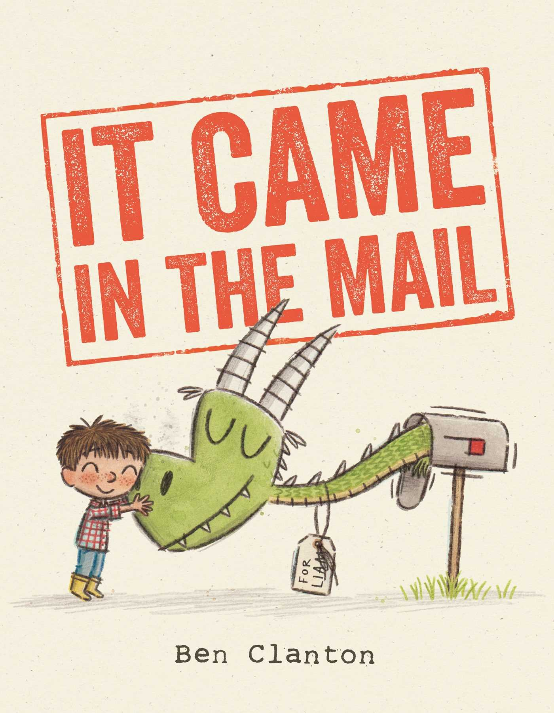
The Road To Love – Debbie Macomber
Renegade’s Pride – B.J. Daniels
16th Seduction – James Patterson
Falling Darkness – Karen Harper
Find Me – J.S. Monroe
The Golden Hour – T. Greenwood
The Last Days – Joel Rosenberg
The Winner’s Crime – Marie Rutkoski
Behold the Fire – Steven Salinger
The Crystal City – Orson Scott Card
The Zookeepers Wife – Diane Ackerman
A Dog’s Way Home – W. Bruce Cameron
The Return of Brody McBride – Jennifer Ryan
Falling for Owen – Jennifer Ryan
Dylan’s Redemption – Jennifer Ryan

INSPIRATIONAL
Miramar Bay – Davis Bunn
Seeds of Faith – Kristin Eckardt
A Love Transformed – Tracie Peterson
The Beloved Hope Chest – Amy Clipston
What the Bishop Saw – Vannetta Chapman
_________________________________________________________________________________________________
NON –FICTION
Two Paths – John Kasich
Trump’s War: His Battle for America –
Michael Savage

163 Best Paleo Slow Cooker Recipes
The Wahls Protocol – Terry Wahls
The Chosen Few – Gregg Zoraya
Ghost Soldiers – Hampton Sides

SUMMER READING PROGRAM
SIGN-UP TODAY!! Students from 4-12 years old will enjoy fun stories, activities, crafts and snacks as well as meet some of our local community members who will be sharing what they are doing to ‘Build a Better World’!
June 15 @ 5pm-7pm: KICK-OFF 5pm: Final Registration & Activities 5:30pm: Movie & Pizza
‘THE LORAX’
June 22 @ 1pm – 2:30pm: VOLUNTEERING – Mike Davis
Adopt a Neighbor
June 29 @ 1pm – 2:30pm: COMMUNITY CLUBS – Zona Hutson & 4H Leaders
STEM Activities
July 6 @ 1pm – 2:30pm: MILITARY – Local Active Duty & Veterans
Card Making
July 13 @ 1pm – 2:30pm: AMERICORP – Jennifer Wilt
Potted Plants
July 20 @ 1pm-2:30pm: CHILDREN’S THEATRE – Come dressed up like you’re 100 years old!
Mom, Dad, Grandma, and Grandpa you don’t want to miss this! We’ll be acting out Wilfred Gordon McDonald Partidge by Mem Fox; a humorous and touching story of a little boy who lives next to an ‘old people’s home’.
July 22 @ 10am-1pm: PAINT PARTY – Lisa Ball (Participants with Outstanding Completion.)
Participants who attend 3 or more days and complete the required reading for their age will be able to attend a step-by-step painting class!
July 27 @ 6pm-8pm: PIZZA & POOL PARTY at Doddridge County Park
End of program party - ALL participants are welcome!

Summertime Activities

Home Depot FREE hands-on workshops designed for children ages 5 - 12 offered the 1st Saturday of every month at all The Home Depot stores between 9:00 a.m. – 12:00 p.m. Workshops teach children do-it-yourself skills, tool safety and instill a sense of pride and accomplishment. All kids get to keep their craft and receive a FREE Kids Workshop Apron, commemorative pin and certificate of achievement. Children must be present at the store to participate in the workshop. Click here to register online http://www.homedepot.com/workshops/#store/4803
- Tic Tac Toe Game June 3rd from 9 am-Noon Join our hands-on workshop and you and your child can build a wooden tic-tac-toe game to play with family or friends almost anywhere. Once the project is comlete, your child can personalize their game board and pieces with paint and stickers
Adult Workshops http://www.homedepot.com/workshops/#store/4803 ~ Installing Tile Blacksplash ~ Bottle Opener Game ~ Concrete Serving Tray ~Edible and Raised Garden Beds ~ Installing Wall Tile

FISHING TOURNAMENT Saturday June 3 6:30am-1:00pm Deegan and Hinkle Lakes Park $20 per boat 2 people per boat

Sleepy Hollow ScareFest Saturday, June 17 10AM-8PM Four Horsemen Clarksburg presents the Sleepy Hollow ScareFest, Saturday, June 17 from 10am-8pm! The area's first Horror Convention...Admission is FREE, so join us at Meadowbrook Mall for a day of celebrity guests, local film makers, vendors & more! Four Horsemen Comics & Gaming is located across from Marshalls! Celebrity Guests: Addy Miller "Teddy Bear Girl" from The Walking Dead; Steve Dash "The Real Jason" from Friday The 13th Part 2 and Major Harris from "Axeman of Henderson County" & WVU Hall of Fame Plus Meet & Greet the Cast from The Barn and get your photo with the Barn Baddies! If you are a vendor that is interested in participating in the event, please contact mike.sleepyhollowscarefest@gmail.com

Fort New Salem Foundation Events For more information call (304) 695-2220
~ June 3-4 Hammer In- Workshop Weekend ~ July 1, 8, 15, 22, 29 Myths of the Mountains
~ August 11-13 Dulcimer Festival ~ October 6-7 Special Event at Fort
~ November 25-26 Spirit of Christmas in the Mountains
~ December 2-3 Spirit of Christmas in the Mountains.

Music in in the Park SUMMER CONCERT SERIES 2017 FREE CONCERTS 7:00 PM - 8:30 PM JUNE 17 "TASTE OF CLARKSBURG" ENTERTAINMENT - JOSEPH SISTERS 5:00 PM - 9:00 PM CLARKSBURG AMPHITHEATER VETERAN'S MEMORIAL PARK. If the weather looks threatening Concert will be cancelled. It is the discretion of the City Parks to decide whether the event will be called off due to inclement weather. Concerts will be rescheduled for a later date.

Movies in the Park at the Clarksburg AMP- Veterans memorial Park. Concession are available and movies will start at dusk. Weather Cancellation: If the weather looks threatening movies will be cancelled. It is the discretion of the City Parks to decide whether the event will be called off due to inclement weather. Movies will
be rescheduled for a later date. For more information, please contact the Park Office - 304.624.1655 or check for updates on their Facebook page. https://www.facebook.com/CityParksofClarksburg?ref=bookmarks
~ June 9 Storks ~ June 16 THE BFG ~ June 23 Sing ~ July 14 Finding Dory
~ July 21 Secret Life of Pets ~ July 28 Moana

Cinemark Summer Movie ClubHouse 9:30am Tuesdays & Wednesday Cinemark Meadowbrook Mall 10
Fun Films for Kids! $5 for ten movies or $1 per show. All rated G or PG. All Showtimes at 9:30am on Tuesdays & Wednesdays.
- 6/6-6/7 The Secret Life of Pets (PG)
- 6/13-6/14 The LEGO Batman Movie (PG)
- 6/20-6/21 Trolls (PG)7/4-7/5 Goosebumps (PG)
- 7/11-7/12 The Iron Giant (PG)
- 7/17-7/19 Hotel Transylvania 2 (PG)
- 7/25-7/26 Megamind (PG)
- 8/1-8/2 The Angry Birds Movie (PG)
- 8/8-8/9 Sing (PG)

TUESDAY IS FOR TODDLERS Now EVERY Tuesday! Bring your kids up to toddler age to Meadowbrook Mall every Tuesday morning from 11am until Noon for free activities! Enjoy FREE themed activities, character appearances and prizes! It's a great opportunity for your child to interact with other kids their age and loads of holiday fun for everyone! Please visit the Mall Guest Services Desk for details on weekly activities and location of events.

Better than oliverio’s peppers
Kathie Davis

Bell peppers Oil
Hot peppers Salt & pepper
Onions Sweet basil
Garlic Oregano
Tomato sauce or Parsley
Spaghetti sauce Sliced mushrooms

Clean peppers; remove seeds. Cut in bite-size pieces in separate bowls. Peel onions and cut in large pieces. Slice garlic thinly. Heat oil in large skillet. Fry 3 cups sweet peppers, 1 cup hot peppers, 1 large onion and several cloves garlic until tender. Do not overcook. Salt and pepper to taste. Add sauce. Good on hoagies.
If canning, pack in sterile jars and cold pack 5 minutes. Do not pressure cook! Can adjust heat by adding more hot peppers or less.

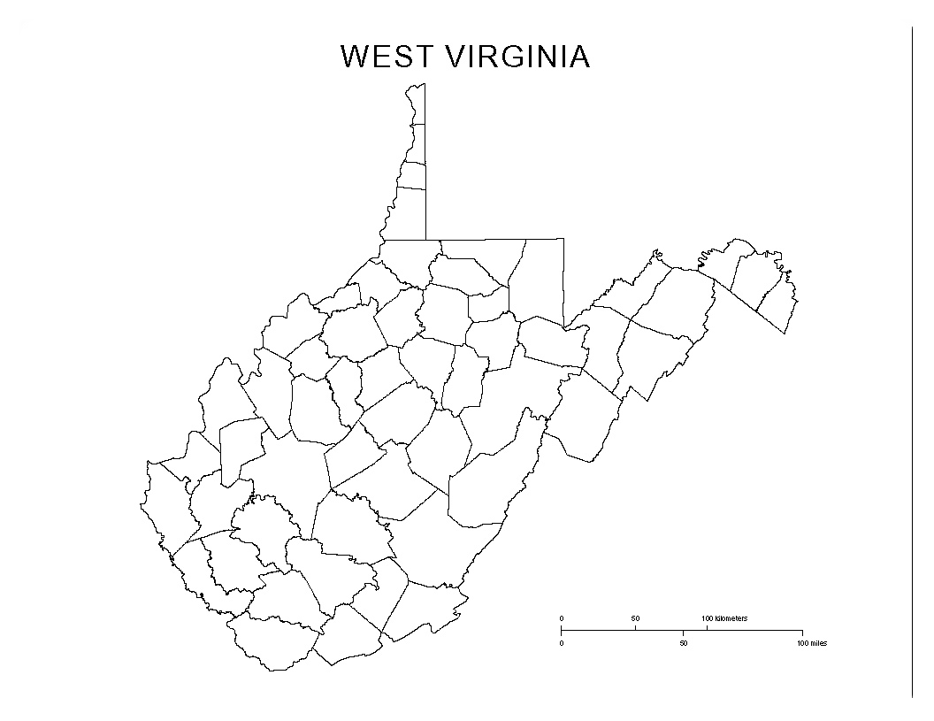

WEST VIRGINIA
How many counties can you fill in?

Barbour
Berkeley
Boone
Braxton
Brooke
Cabell
Calhoun
Clay
Doddridge
Fayette
Gilmer
Jackson
Jefferson
Kanawha
Grant
Greenbrier
Hampshire
Hancock
Hardy
Harrison

Tucker
Tyler
Upshur
Wayne
Webster
Wetzel
Wirt
Wood
Wyoming
Monroe
Morgan
Nicholas
Ohio
Pendleton
Pleasants
Pocahontas
Preston
Putnam
Raleigh
Randolph
Ritchie
Roane
Summers
Taylor

me
Lewis
Lincoln
Logan
McDowell
Marion
Marshall
Mason
Mercer
Mineral
Mingo
Monongalia

Counties by Name
