May 11  5pm-6:30pm  Art Night - Card Making Class | May 26  10am-2pm  Genealogy Workshop
May 12  10am-2pm  Genealogy Workshop | May 27  9am-2pm  Community Yard Sale
May 18
5:30pm-7:00pm
Movie Night - SINGPG

Knit- Wits
The regular meetings will be cancelled over the summer and will resume in fall.
The last regular meeting will be
Thursday, May 11th.

Community Yard Sale
Anyone can sell – No fees – Large Yard – Bring your own tables and tarps
Looking for home based direct sales distributors for Thirty-One, LuLaRoe, Pampered Chef, Essential Oils, Scentsy, etc. Also looking for folks who hand make crafts, quilts, furniture and paintings! Whatever trade or skill you’d like to share!

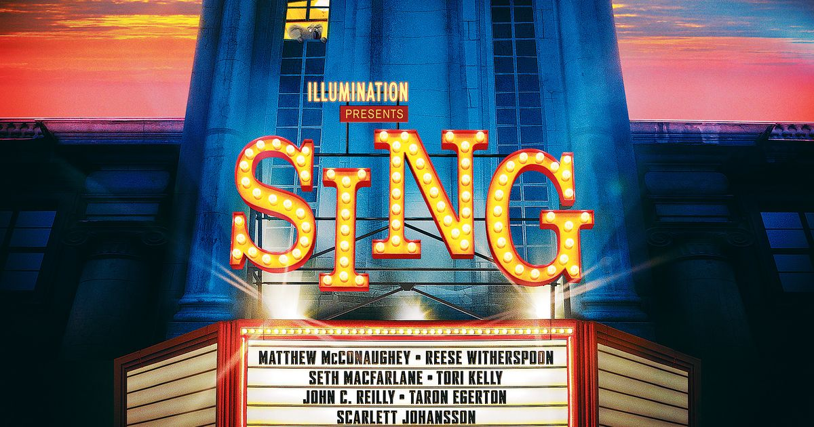
Thursday, May 18 5:30pm-7:00pm
Refreshments provided!!
MOVIE NIGHT
Friday, May 12th & 26th 10am-2pm
If you have ever wanted to try Ancestry.com or wondered where to find information about your ancestry but you weren’t sure how or where to begin, then stop in to the library any time between 10am and 2pm on the above dates. Jennifer Wilt will be
at the library to offer
assistance to anyone
who is interested in
learning more about
their ancestry!

FICTION
NEW SERIES!!
#1 The Third Target - When New York Times foreign correspondent J. B. Collins hears rumors that an al-Qaeda splinter cell--ISIS--has captured a cache of chemical weapons inside Syria, he knows this is a story he must pursue at all costs. Does the commander of the jihadist faction really have weapons of mass destruction?
#2 The First Hostage - “The president of the United States . . . is missing.” With these words, New York Times journalist J. B. Collins, reporting from the scene of a devastating attack by ISIS terrorists in Amman, Jordan, puts the entire world on high alert.

Into Dust – BJ Daniels
Red Clover – Carla Neggers
A Gentleman in Moscow – Amor Towles
The Tea Girl of Hummingbird Lane – Lisa See
Mississippi Blood – Greg Iles
The Devil’s Triangle – Catherine Coulter
The Last Jihad – Joel Rosenberg
The Ezekiel Option – Joel Rosenberg
Before this is Over – Amanda Hickie
Man Overboard – J.A. Jance
The Cutthroat – Clive Cussler
The Winner’s Curse – Marie Rutkoski
Before the Fall – Noah Hawley
Closed Casket – Sophie Hannah
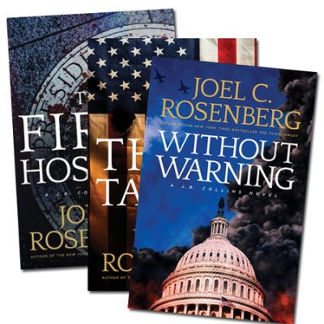
A Perfect Obsession – Heather Graham
Never Let You Go – Chevy Stevens
Dangerous Games – Danielle Steel
Girl in Disguise – Greer Macallister
#3 Without Warning - As he prepares to deliver the State of the Union address, the president of the United States is convinced the Islamic State is on the run, about to be crushed by American forces once and for all. But "New York Times" foreign correspondent J. B. Collins tells the president he's dead wrong. With the Middle East on fire, the Israeli prime minister dead, and Amman in ruins, Collins fears a catastrophic attack inside the American homeland is imminent. He argues that only an all-out manhunt to capture or kill Abu Kahlif--the leader of ISIS--can stop the attack and save American lives. But will the president listen and take decisive action before it's too late?

_________________________________________________________________________________________________
NON –FICTION
Old School – Bill O’Reilly
Hitler’s Last Days – Bill O’Reilly

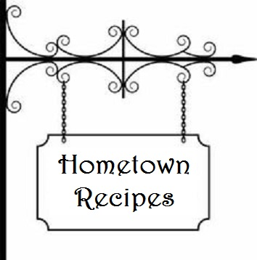
Coconut chews
Kathryn Robinson

½ c. brown sugar 2 Tbsp. flour
½ c. shortening 1 tsp. baking powder
1c. flour ½ tsp. salt
2 eggs, beaten 1c. coconut
½ c. brown sugar 1c. nuts
½ c. dark Karo syrup

Blend ½ c. brown sugar, ½ c. shortening and 1c. flour. Pat mixture in bottom of ungreased 9x9x2 in. pan. Bake at 350 degrees for 10 minutes. Meanwhile blend eggs, brown sugar and Karo syrup. Add flour, baking powder, salt, coconut and nuts. Mix well and spread over bottom layer. Return to oven and bake 25 minutes or until brown. Cool and cut into bars.

MAY TRIVIA QUIZ

- The early Roman calendar had the month of May as the ________ month of the year.
- According to many sources, May was named after which Roman goddess?
- The Empire State Building first opened on May 1st of what year?
- What is the birthstone for May?
- What is the birth flower for May?
- Minnesota was admitted to the Union on May 11th of what year?
- Mother’s Day is celebrated each year on the ______ Monday of May.
- The most famous horse race in the United States took place on the 1st Saturday in May each year. Name it.
1. Third. Later, it became the 5th month of the year. 5. Lily of the Valley
2. Maia. She was the Roman goddess of growth. 6. 1858
3. 1931 7. 2cnd Mother’s Day was first celebrated in 1908
4. Emerald 8. The Kentucky Derby

